**CAED LAB 09**

NAME: RABIA ID: FA17-BECE-2001

**EXERCISE 1:** **Apply filter to the salt & pepper image using MATLAB Commands.**

**CODE:**

s=imread("Shary.png");

s_noise = imnoise(s,"salt & pepper",0.05);

imshow(s_noise)

**SNIP:**

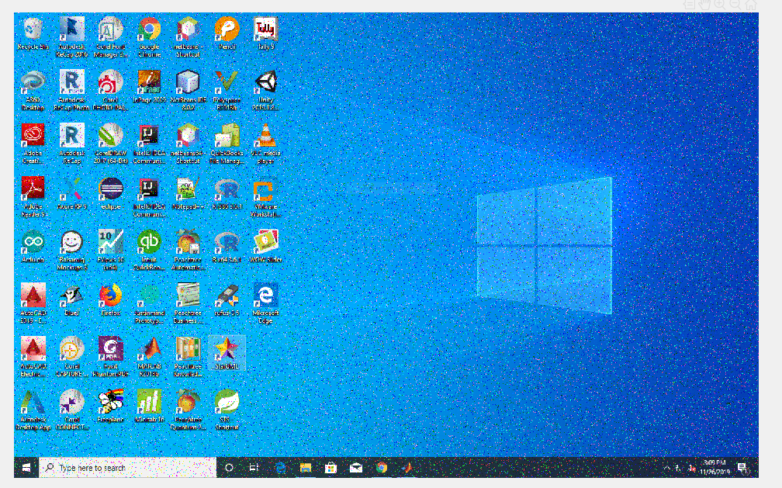

**EXERCISE 2:** **Add Gaussian noise on grayscale image using MATLAB Commands.**

**CODE:**

m=imread("Shary.png");

m2=rgb2gray(m);

m_noise = imnoise(m2,'gaussian',0.05);

imshow(m_noise);

**SNIP:**

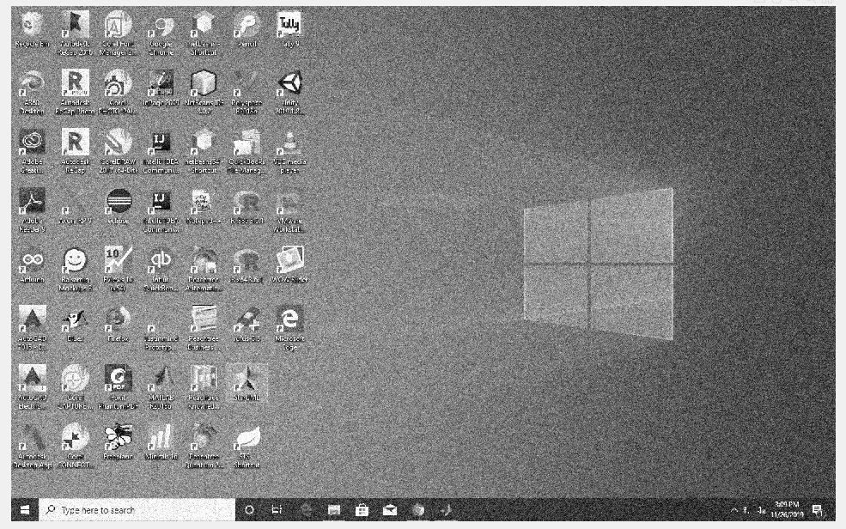

**EXERCISE 3:** **Apply filter to the Gaussian image using MATLAB Commands.**

**CODE:**

s=imread("Shary.png");

s_noise = imnoise(s,'gaussian');

imshow(s_noise);

**SNIP:**

